Janken Soccer

Yes, I **was!**

Were you listen**ing** to music?



Goal!



Goal!

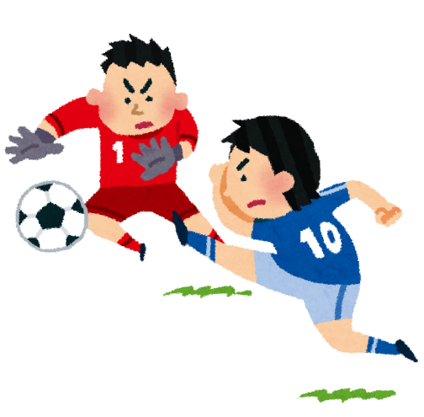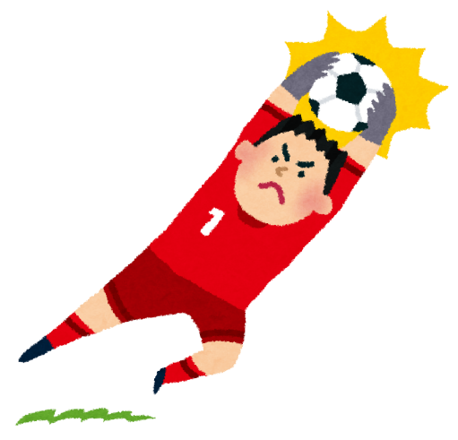

## Unit Reference

  
Cook

  
Eat

  
Study

  
Drink

  
Listen

Janken Soccer

Yes, I **was!**

Were you listen**ing** to music?

## Unit Reference

## C:\Users\paulh\AppData\Local\Microsoft\Windows\INetCache\Content.Word\ball02_white.pngC:\Users\paulh\AppData\Local\Microsoft\Windows\INetCache\Content.Word\yajirushi12_left_right.pngC:\Users\paulh\AppData\Local\Microsoft\Windows\INetCache\Content.Word\ball02_white.pngC:\Users\paulh\AppData\Local\Microsoft\Windows\INetCache\Content.Word\yajirushi12_left_right.pngC:\Users\paulh\AppData\Local\Microsoft\Windows\INetCache\Content.Word\yajirushi12_left_right.pngC:\Users\paulh\AppData\Local\Microsoft\Windows\INetCache\Content.Word\ball02_white.png



Goal!



Goal!



  
Listen

  
Drink

  
Study

  
Eat

  
Cook

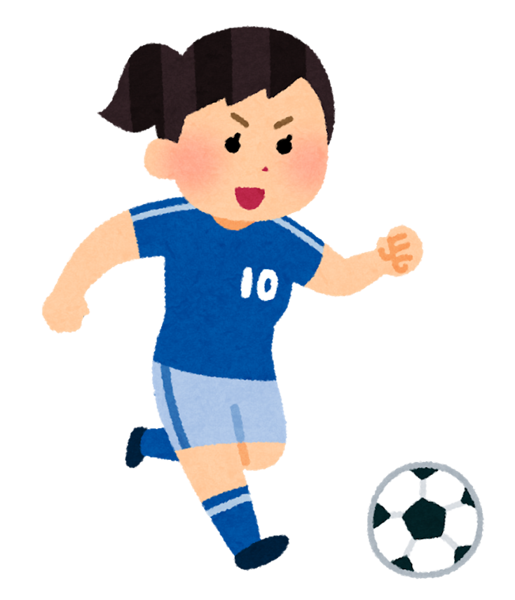  
Play

  
Watch

  
Read