Alphabet  
「アルファベット」



Please write these letters!

「これらのをいてください！」

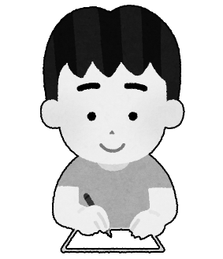

A

|  |  |  |  |  |  |
| --- | --- | --- | --- | --- | --- |
| A | B | C | D | E | F |

|  |  |  |  |  |  |
| --- | --- | --- | --- | --- | --- |
| |  | | --- | |  | | |  | | --- | |  | | |  | | --- | |  | |
| |  | | --- | |  | | |  | | --- | |  | | |  | | --- | |  | |

Please cut out your letters!

「あなたのをカットしてください！」

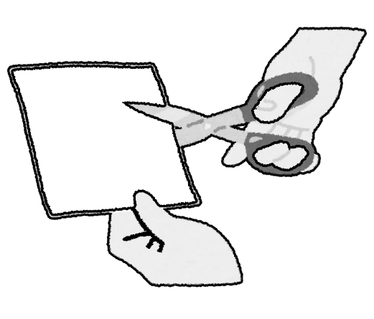

A