|  |  |  |  |  |  |
| --- | --- | --- | --- | --- | --- |
| **1** | **at** | **an** | **ap** | **ad** | **am** |
| **B** |  |  |  |  |  |
| **S** |  |  |  |  |  |
| **M** |  |  |  |  |  |
| **P** |  |  |  |  |  |
| **C** |  |  |  |  |  |

|  |  |  |  |  |  |
| --- | --- | --- | --- | --- | --- |
|  | **at** | **an** | **ap** | **ad** | **am** |
| **B** |  |  |  |  |  |
| **S** |  |  |  |  |  |
| **M** |  |  |  |  |  |
| **P** |  |  |  |  |  |
| **C** |  |  |  |  |  |



**2**

**PHONICS BATTLESHIP**

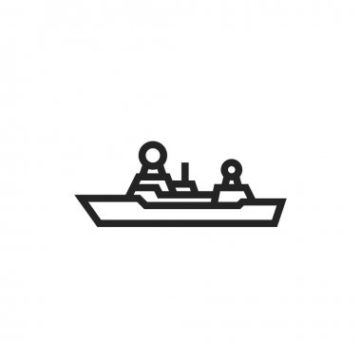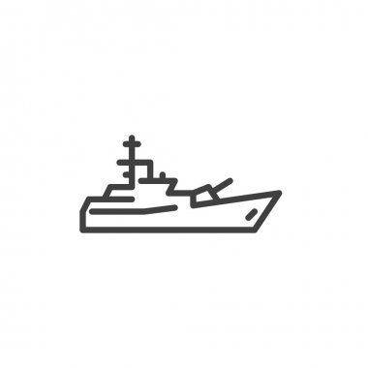

HIT!

MISS!

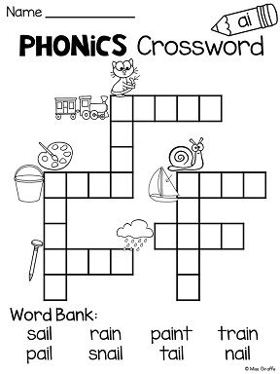_________________________________

CHALLENGE!

Can you write the words in the boxes?

