Tree Game

Unit Reference
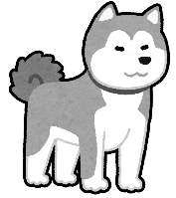 |  |  | 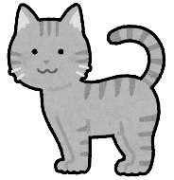 |  |  |  |  | 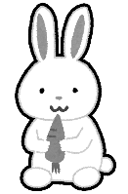 |  |  |  |  |  |  |  |  |  |  | 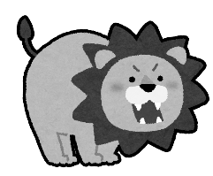 |  |  |  | 
 | 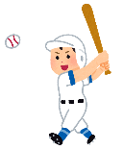 |  |  |  |  |  |  |  |  |  |  |  |  |  |  |  |  |  |  |  |  | 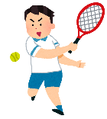
 | baseball |  |  |  | volleyball |  |  |  |  |  | golf |  |  |  |  |  | basketball |  |  |  |  | tennis
 |  |  |  |  |  |  | 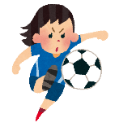
 |  | tennis |  |  |  |  | soccer |  |  |  |  |  |  | volleyball |  |  |  |  |  | golf
 |  |  |  | 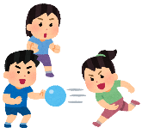 |  |  |  |  |  |  |  |  |  |  | 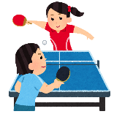
 |  |  |  | dodgeball |  |  |  |  | tennis |  |  |  |  |  | table tennis
   |  |  |  |  |  |  |  |  |  |  |  | 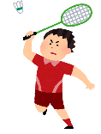 |  |  |  |  |  |  |  |  |  |  |  | 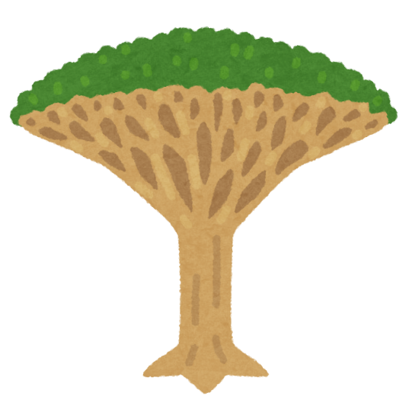
 |  |  |  |  |  | table tennis |  |  |  |  |  | badminton
 |  |  |  | Start!
 |  |  |  |  |  |  |  |  |  | baseball

