|  |
| --- |
|  |

|  |  |  |
| --- | --- | --- |
| will |  | it’s |
| rainy | If | an |
| , | use | I |

Example: If it’s rainy, I will use an umbrella!

|  |
| --- |
|  |

|  |  |  |
| --- | --- | --- |
| 1 | 1 | 1 |
| I | a | will |
| 1 | 1 | 1 |
| cook | am | I |
| 1 | 1 | 1 |
| hungry |  | If |

If I am hungry, I will cook a pizza.

|  |
| --- |
|  |

|  |  |  |
| --- | --- | --- |
| 2 | 2 | 2 |
| will | the | If |
| 2 | 2 | 2 |
| sunny | go |  |
| 2 | 2 | 2 |
| to | it’s | I |

If it’s sunny, I will go to the beach!

|  |
| --- |
|  |

|  |  |  |
| --- | --- | --- |
| 3 | 3 | 3 |
| can |  | we |
| 3 | 3 | 3 |
| English | If | American |
| 3 | 3 | 3 |
| watch | learn | we |

If we watch America movies, we can learn English!

|  |
| --- |
|  |

|  |  |  |
| --- | --- | --- |
| 4 | 4 | 4 |
| you | listen | like |
| 4 | 4 | 4 |
| should | Twice | to |
| 4 | 4 | 4 |
|  | music | If you |

If you like Korean music, you should listen to Twice.

|  |
| --- |
|  |

|  |  |  |
| --- | --- | --- |
| 5 | 5 | 5 |
|  | If | to |
| 5 | 5 | 5 |
| tonight | go | early |
| 5 | 5 | 5 |
| bed | I’ll | I’m |

If I’m tired (sleepy), I’ll go to bed early tonight.

|  |
| --- |
|  |

|  |  |  |
| --- | --- | --- |
| 6 | 6 | 6 |
| am | play | If |
| 6 | 6 | 6 |
| sad | my | with |
| 6 | 6 | 6 |
| I |  | I’ll |

If I am sad, I’ll play with my dog.

|  |
| --- |
|  |

|  |  |  |
| --- | --- | --- |
| 7 | 7 | 7 |
| like |  | that |
| 7 | 7 | 7 |
| please | anime | read |
| 7 | 7 | 7 |
| If | this | you |

If you like that anime, please read this comic!

|  |
| --- |
|  |

|  |  |  |
| --- | --- | --- |
| 8 | 8 | 8 |
| practice | the | can |
| 8 | 8 | 8 |
| win | we | If |
| 8 | 8 | 8 |
| we | tournament |  |

If we practice volleyball, we can win the tournament!

|  |
| --- |
|  |

|  |  |  |
| --- | --- | --- |
| 9 | 9 | 9 |
| let’s | difficult | is |
| 9 | 9 | 9 |
|  | study | together |
| 9 | 9 | 9 |
| think | you | If |

If you think math is difficult, let’s study together!

|  |
| --- |
|  |

|  |  |  |
| --- | --- | --- |
| 10 | 10 | 10 |
| in | a | you |
| 10 | 10 | 10 |
| use | If you | arrive |
| 10 | 10 | 10 |
| will | 20 minutes |  |

If you use a train, you will arrive in 20 minutes.

|  |
| --- |
|  |

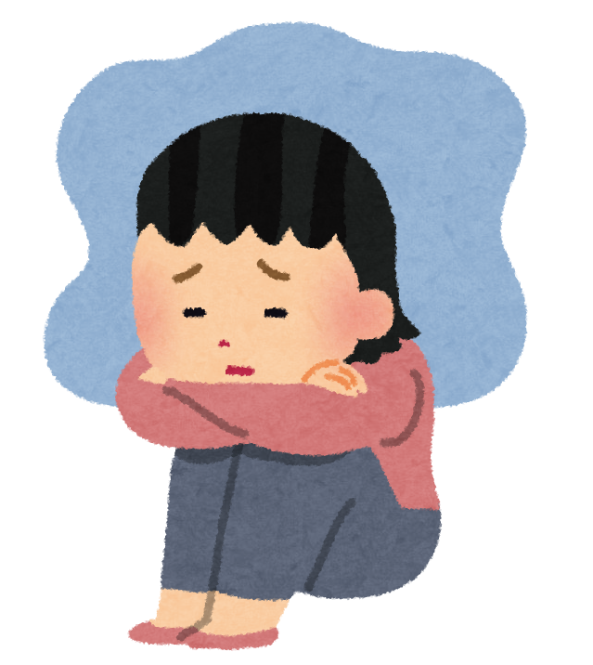

|  |  |  |
| --- | --- | --- |
| 11 | 11 | 11 |
| If | Ms. Oba | study |
| 11 | 11 | 11 |
| English | will |  |
| 11 | 11 | 11 |
| don’t | be | I |

If I don’t study English, Ms. Oba will be sad.

|  |
| --- |
|  |

|  |  |  |
| --- | --- | --- |
| 12 | 12 | 12 |
| today |  | , |
| 12 | 12 | 12 |
| free | together | If |
| 12 | 12 | 12 |
| play | you’re | let’s |

# If you’re free today, let’s play video games together!

# Unit 3 Part 3 Conditional Clause

Double Puzzle Answers

Demo) If it’s rainy, I will use an umbrella.   
1) If I am hungry, I will cook a pizza.  
2) If it’s sunny, I will go to the beach.  
3) If we watch American movies, we can learn English!  
4) If you like Korean music, you should listen to Twice.  
5) If I’m tired (sleepy), I’ll go to bed early tonight.  
6) If I am sad, I’ll play with my dog.  
7) If you like that anime, please read this comic!  
8) If we practice volleyball, we can win the tournament!  
9) If you think math is difficult, let’s study together.  
10) If you use a train, you will arrive in 20 minutes.  
11) If I don’t study English, Ms. Oba will be sad.  
12) If you’re free today, let’s play video games together!

# Unit 3 Part 3 Conditional Clause

Double Puzzle



If it rains, I’ll use an **umbrella!**

**it**

**If**

1. Secret word:

Answer:

1. Secret word:

Answer:

1. Secret word:

Answer:

1. Secret word:

Answer:

1. Secret word:

Answer:

1. Secret word:

Answer:

1. Secret word:

Answer:

1. Secret word:

Answer:

1. Secret word:

Answer:

1. Secret word:

Answer:

1. Secret word:

Answer:

1. Secret word:

Answer: