Read and Run

## Unit 1 Part 3: When

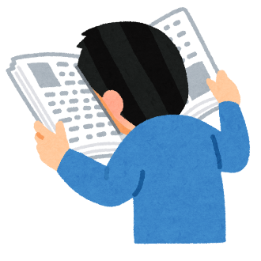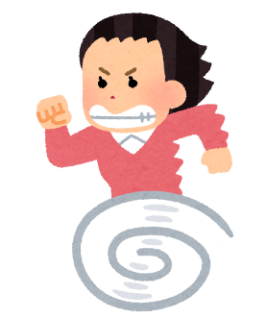1. What do you do **when** it’s rainy?

I **when** it’s rainy.

2. What do you do **when** you go to the movie theater?

I **when** I go to the movie theater.

3. What do you do **when** you go to the swimming pool?

4. What do you do **when** you want to sing?

5. **When** you have a test, what do you do?

**When** I have a test, I

6. **When** you’re hungry, what do you do?

7. **When** do you go shopping?

I go shopping **when**

8. **When** do you visit the doctor?

9. **When** do you get presents?

Read and Run Answers

## Unit 1 Part 3: When

1. What do you do **when** it’s rainy?

I usa an umbrella **when** it’s rainy.

2. What do you do **when** you go to the movie theater?

I eat popcorn **when** I go to the movie theater.

3. What do you do **when** you go to the swimming pool?

I swim when I go to the swimming pool.

4. What do you do **when** you want to sing?

I go to karaoke when I want to sing.

5. **When** you have a test, what do you do?

**When** I have a test, I study hard.

6. **When** you’re hungry, what do you do?

When I’m hungry, I eat ramen.

7. **When** do you go shopping?

I go shopping **when** I have money!

8. **When** do you visit the doctor?

I visit the doctor when I feel sick!

9. **When** do you get presents?

I get presents when it’s my birthday!

|  |  |  |
| --- | --- | --- |
| I use an umbrella. | I eat popcorn. | I swim. |
| I go to karaoke. | I study hard. | I eat ramen. |
| I have money! | I feel sick! | It’s my birthday! |