True or Lie?!

## Textbook Reference

|  |  |  |  |
| --- | --- | --- | --- |
| 2 x True |  | 1 x Lie |  |

### Example:

|  |  |  |
| --- | --- | --- |
| C:\Users\paulh\Google Drive\Documents\Lesson Plans\Lesson Materials\Numbers\number_1.png | C:\Users\paulh\Google Drive\Documents\Lesson Plans\Lesson Materials\Numbers\number_2.png | C:\Users\paulh\Google Drive\Documents\Lesson Plans\Lesson Materials\Numbers\number_3.png |
| 1. Sentence 1. | 2. Sentence 2. | 3. Sentence 3. |

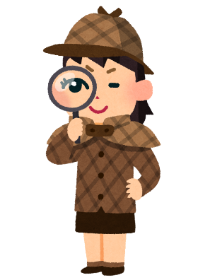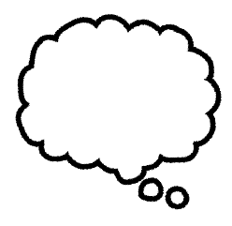

1. .
2. .
3. .



|  |  |  |  |
| --- | --- | --- | --- |
| **Name** | **1st try** | **2nd try** | **3rd try** |
|  | 3 | 2 | 1 |
|  | 3 | 2 | 1 |
|  | 3 | 2 | 1 |
|  | 3 | 2 | 1 |
|  | 3 | 2 | 1 |
|  | 3 | 2 | 1 |
|  | 3 | 2 | 1 |
|  | 3 | 2 | 1 |
|  | 3 | 2 | 1 |
|  | 3 | 2 | 1 |
|  | 3 | 2 | 1 |
|  | 3 | 2 | 1 |

How many points do you have?