Asleep/Awake

r

a

## https://2.bp.blogspot.com/-zDK3IgNsuQM/W-0gxRewoBI/AAAAAAABQMo/I2cf6rYG7vQ2fVy_V0qqNGBOjbRptc12wCLcBGAs/s800/kaigi_school_gakuran.pnghttps://2.bp.blogspot.com/-Cmvu1wHYjQk/UOFKCAktHsI/AAAAAAAAKDs/29TPBCRpLv4/s1600/bunbougu_kokuban.pnghttps://2.bp.blogspot.com/-VgYC4gsyGwI/WGYjhkT_E3I/AAAAAAABAzA/zVdKQEOTis4DvxGf9pqynSO02-6ozCgRACLcB/s800/school_inemuri.png

e

m

e

n

-----------------------------------------------------------------------------------------------------------------------------------------------------------

My letter is…

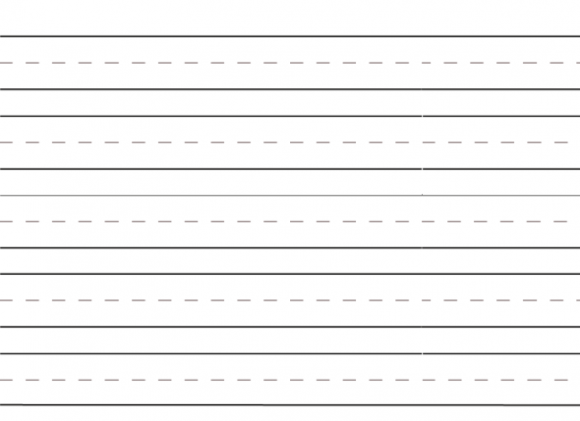

Round 1



Our word is…



-----------------------------------------------------------------------------------------------------------------------------------------------------------

My letter is…



Round 2



Our word is…



-----------------------------------------------------------------------------------------------------------------------------------------------------------

My letter is…



Round 3



Our word is…



My letter is…



Round 4



Our word is…



-----------------------------------------------------------------------------------------------------------------------------------------------------------

My letter is…



Round 5



Our word is…



-----------------------------------------------------------------------------------------------------------------------------------------------------------

My letter is…



Round 6



Our word is…





**WELL DONE**