During winter vacation, I

___________________________________ .

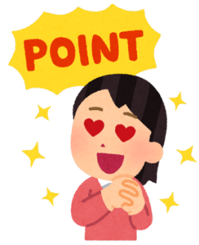

**POINTS**

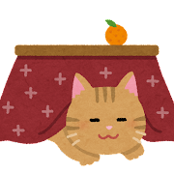

During winter vacation, I

___________________________________ .



**POINTS**

